**PROGRAM 5.**

**AIRLINE FLIGHT DATABASE**

**Consider the following database that keeps track of airline flight information:**

**FLIGHTS (flno: integer, from: string, to: string, distance: integer, departs: time, arrives: time, price: integer)**

**AIRCRAFT (aid: integer, aname: string, cruisingrange: integer)**

**CERTIFIED (eid: integer, aid: integer)**

**EMPLOYEE (eid: integer, ename: string, salary: integer)**

use Supriya;

CREATE TABLE flights

(

flno INTEGER PRIMARY KEY,

ffrom VARCHAR(15) NOT NULL,

tto VARCHAR(15) NOT NULL,

distance INTEGER,

departs TIMESTAMP,

arrives TIMESTAMP,

price float(10));

desc flights;

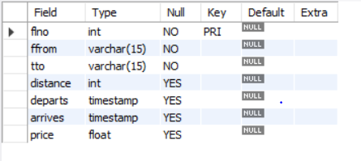

CREATE TABLE aircraft

(

aid INTEGER PRIMARY KEY,

aname VARCHAR(10),

cruising_range INTEGER);

desc aircraft;

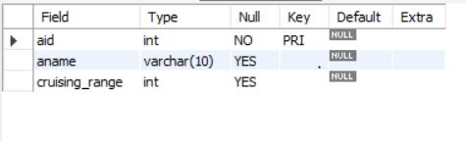

CREATE TABLE employee

(

eid INTEGER PRIMARY KEY,

ename VARCHAR(15),

salary INTEGER(10));

desc employee;

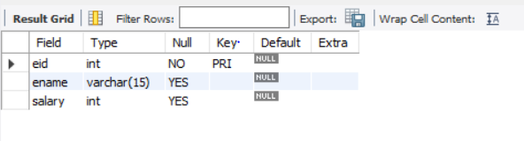

CREATE TABLE certified

(

eid INTEGER NOT NULL,

aid INTEGER NOT NULL,

PRIMARY KEY (eid,aid),

FOREIGN KEY (eid) REFERENCES employee (eid), FOREIGN KEY (aid) REFERENCES aircraft (aid));

desc certified;

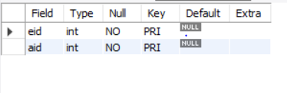

insert into flights values(1,'hubli','bangalore',250,'2005-05-13 07:15:31','2005-05-13 10:15:31','2500.5');

insert into flights values(2,'dharwad','bangalore',260,'2006-05-13 07:15:31','2006-05-13 10:15:31','3500.5');

insert into flights values(3,'tumkur','hubli',300,'2007-05-13 07:15:31','2007-05-13 10:15:31','4500.5');

insert into flights values(4,'mangalore','bangalore',350,'2008-05-13 07:15:31','2008-05-13 10:15:31','1500.5');

insert into flights values(5,'delhi','mysore',650,'2005-05-13 07:15:31','2005-05-13 10:15:31','6500.5');

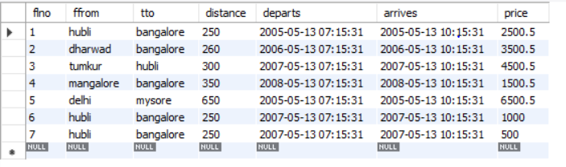

insert into aircraft values(1,'100','900');

insert into aircraft values(2,'150','1000');

insert into aircraft values(3,'200','1200');

insert into aircraft values(4,'250','1300');

insert into aircraft values(5,'300','1500');

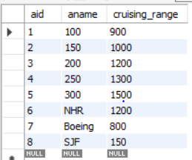

insert into employee values(1,'A',1000);

insert into employee values(2,'B',2000);

insert into employee values(3,'C',3000);

insert into employee values(4,'D',4000);

insert into employee values(5,'A',1000);

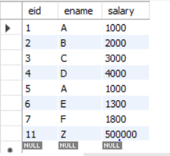

insert into certified values(1,1);

insert into certified values(2,2);

insert into certified values(3,3);

insert into certified values(4,4);

insert into certified values(5,5);

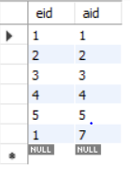

**i)Find the names of aircraft such that all pilots certified to operate them have salaries more than Rs.2000**

SELECT DISTINCT A.aname

FROM aircraft A

WHERE A.aid IN (SELECT C.aid

FROM certified C,employee E

WHERE C.eid = E.eid AND

EXISTS( SELECT *

FROM employee E1

WHERE E1.eid = E.eid AND E1.salary>2000));

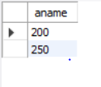

**ii)For each pilot who is certified for more than one aircrafts, find the eid and the maximum cruising range of the aircraft for which she or he is certified**

SELECT C.eid, MAX(A.cruising_range)

FROM certified C,aircraft A

WHERE C.aid = A.aid

GROUP BY C.eid

HAVING COUNT(*)>1;



**iii)Find the names of pilots whose salary is less than the price of the cheapest route from delhi to mysore.**

SELECT DISTINCT E.ename

FROM employee E

WHERE E.salary<( SELECT MIN(F.price)

FROM flights F WHERE F.ffrom='delhi' AND F.tto='mysore');

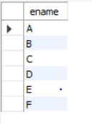

**iv)For all aircraft with cruising range over 1000 Kms, find the name of the aircraft and the average salary of all pilots certified for this aircraft.**

SELECT Temp.name,Temp.AvgSalary

FROM (SELECT A.aid, A.aname AS name, AVG(E.salary) AS AvgSalary

FROM aircraft A,certified C,employee E

WHERE A.aid = C.aid AND C.eid = E.eid AND A.cruising_range>1000

GROUP BY A.aid, A.aname )Temp;

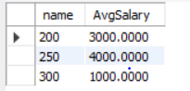

**v)Find the names of pilots certified for ‘300’ named aircraft.**

SELECT DISTINCT E.ename

FROM employee E, certified C, aircraft A

WHERE E.eid = C.eid AND C.aid = A.aid AND A.aname LIKE '300';

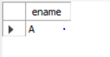

**vi)Find the aids of all aircraft that can be used on routes from tumkut to hubli.**

SELECT A.aid

FROM aircraft A

WHERE A.cruising_range>(SELECT MIN(F.distance)

FROM flights F WHERE F.ffrom ='tumkur' AND F.tto='hubli');

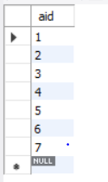

**vii)A customer wants to travel from Madison to New York with no more than two changes of flight. List the choice of departure times from Madison if the customer wants to arrive in New York by 6 p.m.**

SELECT F.departs

FROM flights F

WHERE F.flno IN (( SELECT F0.flno

FROM flights F0

WHERE F0.ffrom ='hubli' AND F0.tto = 'bangalore'

AND extract(hour from F0.arrives)<18 )

UNION

( SELECT F0.flno

FROM flights F0,flights F1

WHERE F0.ffrom = 'hubli' AND F0.tto <>'bangalore'

AND F0.tto = F1.ffrom AND F1.tto ='bangalore'

AND F1.departs > F0.arrives

AND extract(hour from F1.arrives) < 18)

UNION

( SELECT F0.flno

FROM flights F0,flights F1,flights F2

WHERE F0.ffrom ='hubli'

AND F0.tto = F1.ffrom

AND F1.tto = F2.ffrom

AND F2.tto = 'bangalore'

AND F0.tto <> 'bangalore'

AND F1.tto <> 'bangalore'

AND F1.departs > F0.arrives

AND F2.departs > F1.arrives

AND extract(hour from F2.arrives) < 18));

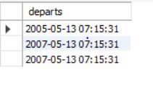

**viii. Print the name and salary of every non-pilot whose salary is more than the average salary for pilots**

SELECT E.ename, E.salary

FROM employee E

WHERE E.eid NOT IN( SELECT DISTINCT C.eid

FROM certified C)

AND E.salary>(SELECT AVG(E1.salary)

FROM employee E1

WHERE E1.eid IN

( SELECT DISTINCT C1.eid

FROM certified C1 ) );

